The Data Pipeline Briefing

Section 1 – System Description and Technical Context

Service Overview
This service is an automated data pipeline intended to securely and efficiently transfer sensitive data payloads from a third-party ingestion service(s) to a private cloud-hosted database, exposing structurally curated datasets to internal tools or client systems via a private API. It is meant to be used solely within the territory of the United Kingdom. The service will be used by administrators acting as processors accommodating end users.

Data Types
Payloads include personal data as defined in Article 4(1) (GDPR, 2018), and no special category data defined in Article 9(1) (GDPR, 2018). Collection, holding, and processing of this information must be explicitly communicated to the data subject via the ingestion provider as stated in Article 13 (GDPR, 2018; ICO, 2024a).

Data Architecture
Data ingestion will be handled by a third-party service who acts as a processor in this exchange. Upon collection, the service will disclose a privacy notice governed by Article 13 (GDPR, 2018 2021). Client-side validation will be incorporated to minimise risk and increase data consistency. Before ingestion is completed and the processor receives submitted data, the client device will encrypt the data using a PGP (Pretty Good Privacy) key stored locally on their device (ICO, 2024c).

Upon successful ingestion, the processor will relay the payload to our API who will then validate the length of the fields in the payload, providing a rudimentary degree of server-side validation. If this step succeeds, the API will make an insert query to our cloud-hosted database via a private network where the database server will be located for security reasons, saving the encrypted data.

An append-only log of the exchange will be made to increase maintainability. In addition to logging, a backup of the database will be made periodically to increase security and minimise the risk. To ensure compliance with the Data Retention Directive, logs will expire after a set amount of time, and backups will be given a cycle schedule consistent with storage limitation principles (ICO, 2024d, Principle (e)).

On retrieval, the processor will structurally curate the encrypted data to accommodate the given view, then the client will curate it transformationally once data is decrypted using the private key stored locally on client’s device.

Tools and Workflow Context
Development and delivery of the data pipeline will be managed through a controlled, collaborative workflow based on Git for version control and a private repository hosted on GitHub. Access to the repository will be governed by role-based permissions aligned with the organisational hierarchy, ensuring that access to sensitive components of the system is permitted only to the authorised personnel (OWASP Foundation, 2021, Art.01).

Due to the compliance-driven and security-sensitive nature of this project – Particularly in dealing with the sensitive user information and its regulatory implications – project management will follow a Waterfall model approach. Ample time and preparation will be allocated to the election of the most appropriate and compatible versions of dependencies to ensure long-lasting and reliable performance and minimise legal risk.
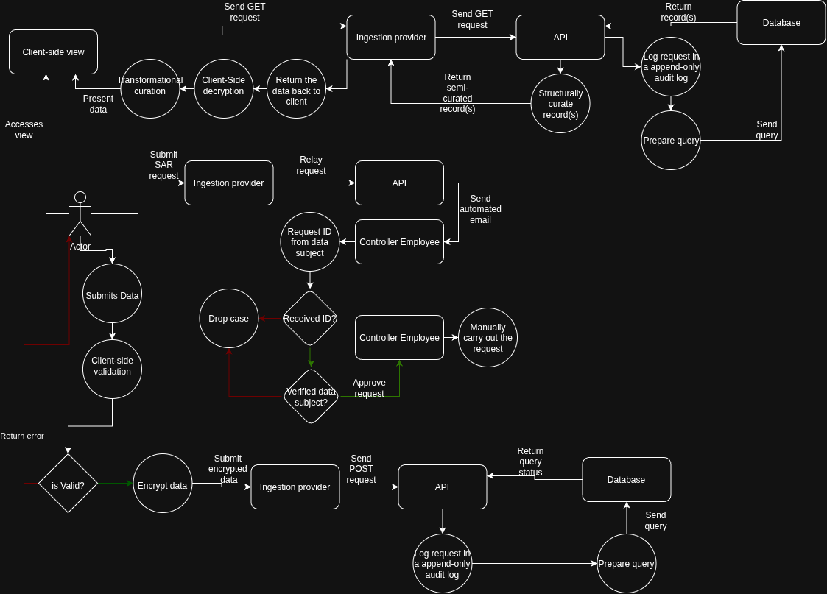

Section 2 – UK GDPR & DPA 2018 Obligations Applied to This Service

Roles and Responsibilities
The organisation operating the API and database would act as the data controller, while the third-party ingestion provider would act as a data processor (GDPR, 2018, Art. 28; ICO, 2024b).

Lawful Basis and Purpose Limitation
The purpose of controlling and processing personal data within this service is to receive and route customer data submitted through the ingestion process, store records securely within the cloud-hosted database, and allow authorised retrieval through our private API for legitimate operational use.

Processing may include reading, creating, updating, and where necessary deleting records (CRUD operations), but only when such operations are necessary to deliver the service or maintain accurate records. No further processing will occur to maintain regulatory obligations.

The primary lawful basis for this processing is the performance of contract under Article 6(1)(b) (GDPR, 2018), wherein contractual obligations require processing of personal data.

A secondary lawful basis may be legitimate interest under Article 6(1)(f) (GDPR, 2018; ICO, 2024g), wherein “processing [of personal information] is necessary for the legitimate interests pursued by the controller or a third party (...)”.

Purpose limitation requires no further processing may be carried out (ICO, 2024d) without a valid lawful basis.

Transparency
Transparency within this service is governed by Article 14 (GDPR, 2018), as personal data is received indirectly from data subjects via a 3rd party ingestion provider,

Ingestion of data (outsourced to a 3rd party endpoint – The collector) is governed by Article 13 (GDPR, 2018) because they collect data directly from data subjects.

A privacy notice will be made available to the data subjects at the moment of data collection or within at most 1 calendar month, via the ingestion provider. It will contain the following information:

- The identity and the contact details of the controller (GDPR, 2018, Art.14(1)(a))
  - Our organisation.
- The purpose of the processing for which the personal data are intended as well as the legal basis for the processing (GDPR, 2018, Art.14(1)(c))
  - Processing necessary for the purposes of the legitimate interest & processing necessary for the performance of a contract to which the data subject is party, under the legal bases of Legitimate Interest & Performance of Contract.
- The categories of personal data concerned (GDPR, 2018, Art.14(1)(d)),
  - Personal data pertaining to data subject within the limits of Article 4(1) (GDPR, 2018).
- The recipients or categories of recipients of the personal data (GDPR, 2018, Art.14(1)(e))
  - Controller organisation, cloud provider, ingestion provider, and authorised internal systems.
- The period for which the personal data will be stored (GDPR, 2018, Art.14(2)(a)),
  - Personal data is retained as long as necessary to provide the service. Records are deleted after 5 years of inactivity (ICO, 2024d; GDPR, 2018, Art.5(1)(c) and Art.5(1)(e)),or earlier if valid erasure request was made by data subject. Subject to any legal or regulatory retention obligations.
- The legitimate interests pursued by the controller or by a third party (GDPR, 2018, Art.14(2)(b)),
  - Maintaining structured datasets to enable authorised retrieval of records.
- The existence of the right to request from the controller access to and rectification or erasure of personal data or restriction of processing concerning the data subject and to object to processing as well as the right to data portability (GDPR, 2018, Art.14(2)(c)),
- The right to lodge a complaint with a supervisory authority (GDPR, 2018, Art.14(2)(e)),
- From which source the personal data originate (GDPR, 2018, Art.14(2)(f)),
  - Personal data originates from third-party ingestion provider acting under instructions of the controller. It is not obtained from publicly accessible sources.
- The existence of automated decision-making (GDPR, 2018, Art.14(2)(g)),
  - No profiling or automated decision-making is carried out. Processing is limited to data routing, storage, and retrieval.

Data Minimisation and Retention
Personal data pertaining to data subject is collected, stored, processed for the purpose of providing service and fulfilling contractual obligations. It is stored in a cloud-hosted database for up to 5 years of inactivity.

After 5 years of inactivity, or upon receiving a valid erasure request from the data subject, all records pertaining to that data subject will be deleted, subject to any legal or regulatory retention obligations. Upon erasure, active records and associated identifiers will be deleted, while personal data contained in logs or backups will be removed or expire in accordance with defined log retention and backup rotation schedules.

We do not collect, store, or process any special category data defined in Article 9(1) (GDPR, 2018). Processing of this type of data without a valid Article 9 condition and Article 6 lawful basis is strictly prohibited.

Data minimisation is supported through database schema normalisation up to the third normal form to eliminate partial and transitive dependencies and impose atomicity, fixed API schemas that restrict submissions to required fields only, and the use of unique user IDs to reduce duplication (ICO, 2024d).

Data Subject Rights
Users have the right to ask for access to their personal information stored in our cloud-hosted database, or that which is currently being processed, as stated in Article 15 (GDPR, 2018). Whenever they choose to do so, they may launch a subject access request (SAR) to the controller (ICO, 2024h). The ingestion endpoint provider (our processor) has the contractual obligation to facilitate such demand as stated in Article 28(3)(e) (GDPR, 2018).

Facilitation of this demand will take the form of establishing a specialised endpoint on the ingestion provider’s side (frontend). This endpoint will be equipped with a SAR form that the user can fill out and submit to us. To ensure both-ways communication, the form will contain required contact fields so we can reach back to the actor upon receiving the request.

Once a request is received on our end, we will first need to verify that person’s identity to prevent fraud. To do so, a counter-request will be made to obtain an appropriate form of identification (ICO, 2024h). Upon successful verification, we will be legally required to comply with the request if the nature of the request is stipulated under Article 15(1) (GDPR, 2018).

Security of Processing
To ensure confidentiality, end-to-end encryption (E2EE) will be implemented. Data will be encrypted in transit and in storage using PGP (Pretty Good Privacy) encryption, and the client’s own private key which will never leave their device (ICO, 2024c). This vastly mitigates the threat of man-in-the-middle (MITD) attacks and prevent both the processors and the controller from being able to view client’s personal information.
To allow client access on multiple devices, the pair of PGP keys will be seeded using a strong passphrase known only to the client.

Role-based access control (RBAC) system will be implemented in our API to ensure that processor administrators cannot access personal information they handle. All they’ll be able to see about each exchange is the record ID.

Access to the API is granted by manually registering the trusted processors with it. Upon successful registration, the processor will be granted an appropriate role suitable for their range of responsibilities. To revoke access, processors’ accounts will be deleted.

To protect integrity of the data, client-side and server-side validation will be incorporated at ingestion. Strict role-based access control will prevent unauthorised tampering. Each CRUD action will generate a timestamped append-only log associated with the individual’s accounts or service to detect unauthorised modification and support accountability.

To strengthen availability, and protect the system against denial of service (DoS) attacks (OWASP Foundation, n.d(a)) fail2ban will be incorporated so if an actor makes a sufficient number of requests within a set amount of time, they will be banned for a set amount of time as a cooldown. Additionally, a redundant failover server will be set aside in case of an emergency wherein the main server is rendered inoperable.

Backup restoration procedures will be periodically tested, and incident response responsibilities assigned, to reduce the risk that recovery controls fail due to human error or unclear ownership.

Collectively these measures support the security of processing obligations under Article 32 (GDPR, 2018).

Section 3 – Human Factors and Security Failure Modes in DaaS delivery

Developer/Admin Behaviour
A controller developer could accidentally mishandle API keys. Since each processor is given a unique API key, they need to be stored somewhere. A developer could accidentally store the keys in a publicly available document, leading to an unauthorised actor gaining access to the API (OWASP Foundation, 2021, A05).

Operational Practice
A processor could hypothetically deliberately share their API key or account with a friend or a business partner to circumvent the official onboarding process and potential fees. Such an action could lead to financial losses, a gross misuse of customer trust, and in case of an incident, a lack of accountability (OWASP Foundation, 2021, A01).

Organisational Drivers
Our organisation could be competing for a contract with another DaaS company. In such a case, commercial pressure (OWASP Foundation, 2021, A04) would increase, and the project lead would be far more lenient towards the “ship it now” culture. This could lead to our organisation shipping an incomplete or only partially complete product with insufficient security. If that were to happen, our organisation would suffer a substantial loss in PR, employee dissatisfaction due to a more hostile work environment, and legal repercussions.

Section 4 – Risk Register

Risk Description | Likelihood | Impact | Mitigation (Technical + Organisational)
Developer mishandles API keys or commits secrets into repository | Medium | Severe | Store secrets in a secrets manager, amend existing documentation to prohibit hardcoded credentials, enable Git secret scanning, require peer review for code changes, train developers on secure secret handling  (OWASP Foundation, 2021, A05)
Deliberate API key sharing by processors | Low | High | Logging IPs and API tokens used in exchanges,  closely and regularly monitoring logs for offences,  contractual prohibition,  acceptable use policy
Commercial pressure | High | High | Onboarding extra staff to increase development pace without foregoing convention,  automating processes to minimise employee workload
Misconfigured cloud database permissions | Medium | Severe | Encryption in storage,  private network access,  regular configuration audits
Sensitive personal data appears in logs or backups | Low | Medium | Encryption of logs,  encryption of storage,  (OWASP Foundation, 2021, A04)  Developer security training,  regular log audits  (OWASP Foundation, 2021, A09)
Exposure of Sensitive Information to an Unauthorised Actor | High | Medium | Deny requests by default, except for public resources,  Implement RBAC,  prohibit public access to company facilities,  (OWASP Foundation, 2021, A01)

Section 5 – Mitigation Plan: Privacy by Design

Technical Controls
Access to API will be filtered by roles (RBAC). Secrets such as API keys will be managed by a secrets manager, and to further prevent leakage, Git secret scanning will be enabled on the repository (OWASP Foundation, 2021, A01 and A05).
All logs will be encrypted, and sensitive information such as first names or addresses, will be redacted (ICO, 2024d). Logs will be regularly audited to scan for violations, and have a set expiry period to comply with the Data Retention Directive.

Organisational Controls
Peer review will be required to commit any changes to the repository. Employees will be trained on secure secret handling (OWASP Foundation, 2021, A04). Access to the repository will be filtered by roles; e.g. Reviewer, Admin, Developer.

Privacy by Design
Database can be accessed only by the API, and only via a private network. User data is encrypted by the user by a key stored locally on their device both in transit and in storage, ensuring that only the user can view their data. Access to the API is filtered by roles, ensuring that processors don’t have sufficient privileges for unauthorised access. Logs and backups are encrypted by the controller. All secrets are stored inside secrets manager. Git secret scanning is enabled on the repository. These controls support data protection by design (GDPR, 2018, Art.25).

Section 6 – Professional Practice Reflection

Professional Practice Reflection
Completing this assessment has made me realise that in Data-as-a-Service environments, security flaws and compliance failures tend to result not from a lack of technical controls, but rather from administrational issues such as unclear ownership, lack of organisational mitigation steps, or poor access control rules. As presented in the risk register, the consequences of those issues may be quite severe. However, I stand to have learned that the solutions to those problem are quite attainable with fairly limited resource.

I would implement a role-based access control to filter access to sensitive parts of the system, enforce the use secrets managers and enable Git secrets scanning to reduce human error in secret handling, require peer review for code changes and encrypt the logs and backups to minimise insider threats, and implement PGP encryption on subject data so no one except the data subject can view their data. These measures will help minimise people-driven security and potential compliance failures.

I would ensure data protection is maintained through the lifecycle by using a closed beta model with limited test users and synthetic or minimised test data where possible. I would require the testers to sign testing agreements defining processing purposes and responsibilities. This would allow us to locate and patch failure points early while maintaining compliance rather than treating regulatory requirements as an afterthought.

I would prevent the security/privacy requirements being lost during iterative development by breaking them down into milestones in the project timeline, and then ensuring that they’re met at review points during the software development lifecycle. With this methodology, we can bring attention to any outstanding milestones and address the issue as a team. A hypothetical solution to this situation could be rewriting the definition of done.

References

GDPR (2018) General Data Protection Regulation. Available at: https://gdpr-info.eu/ (Accessed: 17 April 2026).
Data Protection Act 2018 (2018) c.12. London: The Stationery Office. Available at: https://www.legislation.gov.uk/ukpga/2018/12 (Accessed: 22 April 2026).
Information Commissioner’s Office (ICO) (2024a) Personal information: What is it? Available at: https://ico.org.uk/for-organisations/uk-gdpr-guidance-and-resources/personal-information-what-is-it/ (Accessed: 22 April 2026).
Information Commissioner’s Office (ICO) (2024b) Controllers and processors. Available at: https://ico.org.uk/for-organisations/uk-gdpr-guidance-and-resources/controllers-and-processors/ (Accessed: 22 April 2026).
Information Commissioner’s Office (ICO) (2024c) Encryption and data transfer. Available at: https://ico.org.uk/for-organisations/uk-gdpr-guidance-and-resources/security/encryption/encryption-and-data-transfer/ (Accessed: 23 April 2026).
Information Commissioner’s Office (ICO) (2024d) Data protection principles. Available at: https://ico.org.uk/for-organisations/uk-gdpr-guidance-and-resources/data-protection-principles/ (Accessed: 23 April 2026).
Information Commissioner’s Office (ICO) (2024f) Lawful basis: Contract. Available at: https://ico.org.uk/for-organisations/uk-gdpr-guidance-and-resources/lawful-basis/a-guide-to-lawful-basis/ (Accessed: 23 April 2026).
Information Commissioner’s Office (ICO) (2024g) Legitimate interests. Available at: https://ico.org.uk/for-organisations/uk-gdpr-guidance-and-resources/lawful-basis/a-guide-to-lawful-basis/legitimate-interests/ (Accessed: 24 April 2026).
Information Commissioner’s Office (ICO) (2024h) Subject access requests. Available at: https://ico.org.uk/for-organisations/uk-gdpr-guidance-and-resources/subject-access-requests/ (Accessed: 25 April 2026).
OWASP Foundation (2021) OWASP Top 10: The Ten Most Critical Web Application Security Risks. Available at: https://owasp.org/Top10/2021/ (Accessed: 25 April 2026).
OWASP Foundation (n.d.(a)) Denial of Service. Available at: https://owasp.org/www-community/attacks/Denial_of_Service (Accessed: 26 April 2026).

